**WEEK-01**

**HANDS ON EXERCISES SOLUTIONS**

DATA STRUCTURES AND ALGORITHMS:

2] Exercise 7: Financial Forecasting

Scenario:

You are developing a financial forecasting tool that predicts future values based on past data.

Steps:

1. Understand Recursive Algorithms:
   * Explain the concept of recursion and how it can simplify certain problems.
2. Setup:
   * Create a method to calculate the future value using a recursive approach.
3. Implementation:
   * Implement a recursive algorithm to predict future values based on past growth rates.
4. Analysis:
   * Discuss the time complexity of your recursive algorithm.
   * Explain how to optimize the recursive solution to avoid excessive computation.

SOLUTION:

DESCRIPTION:

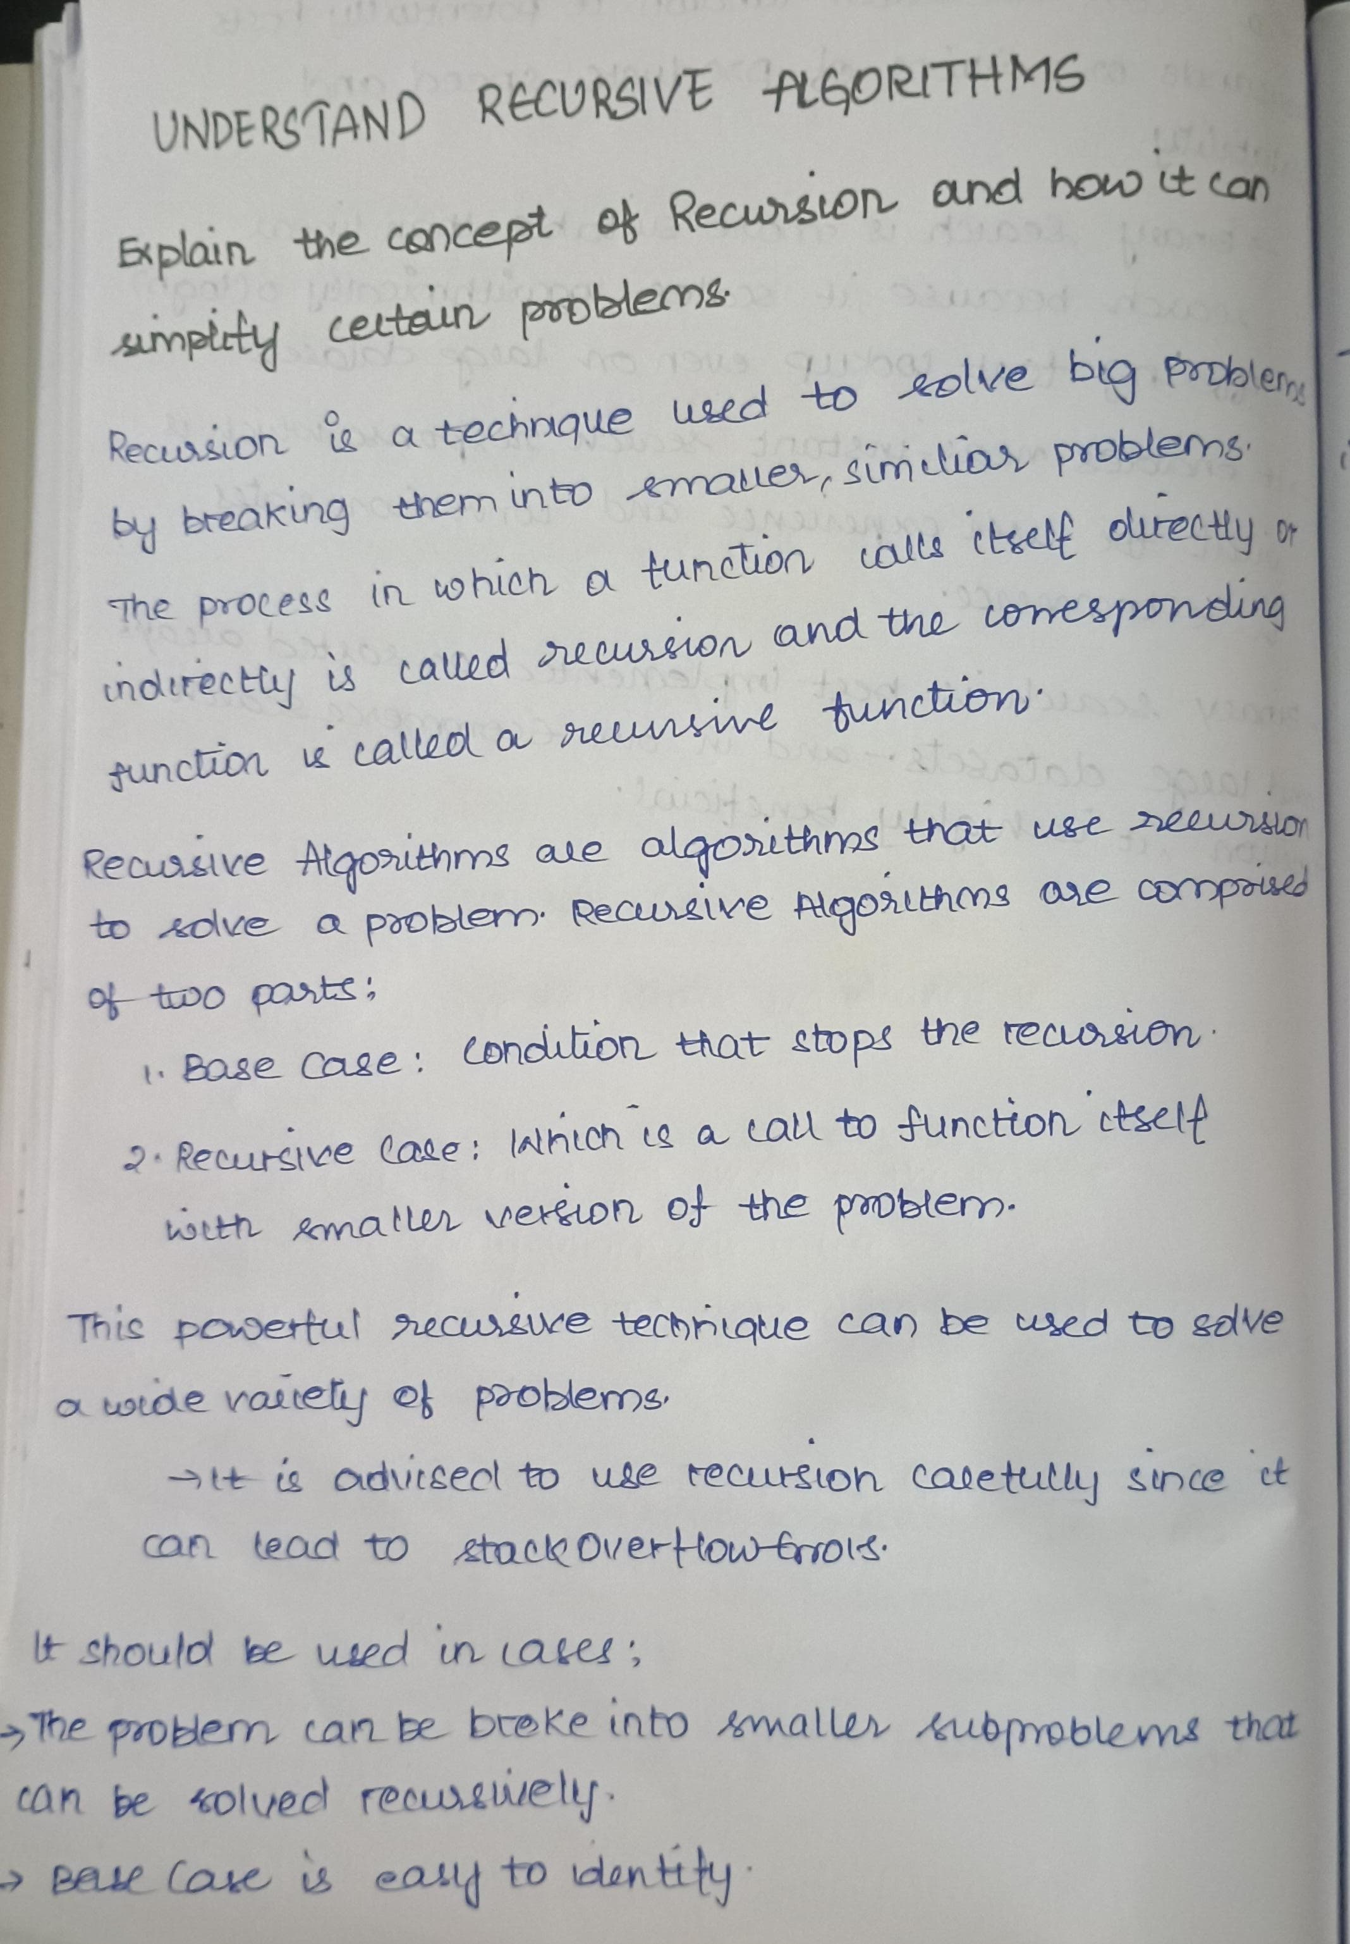

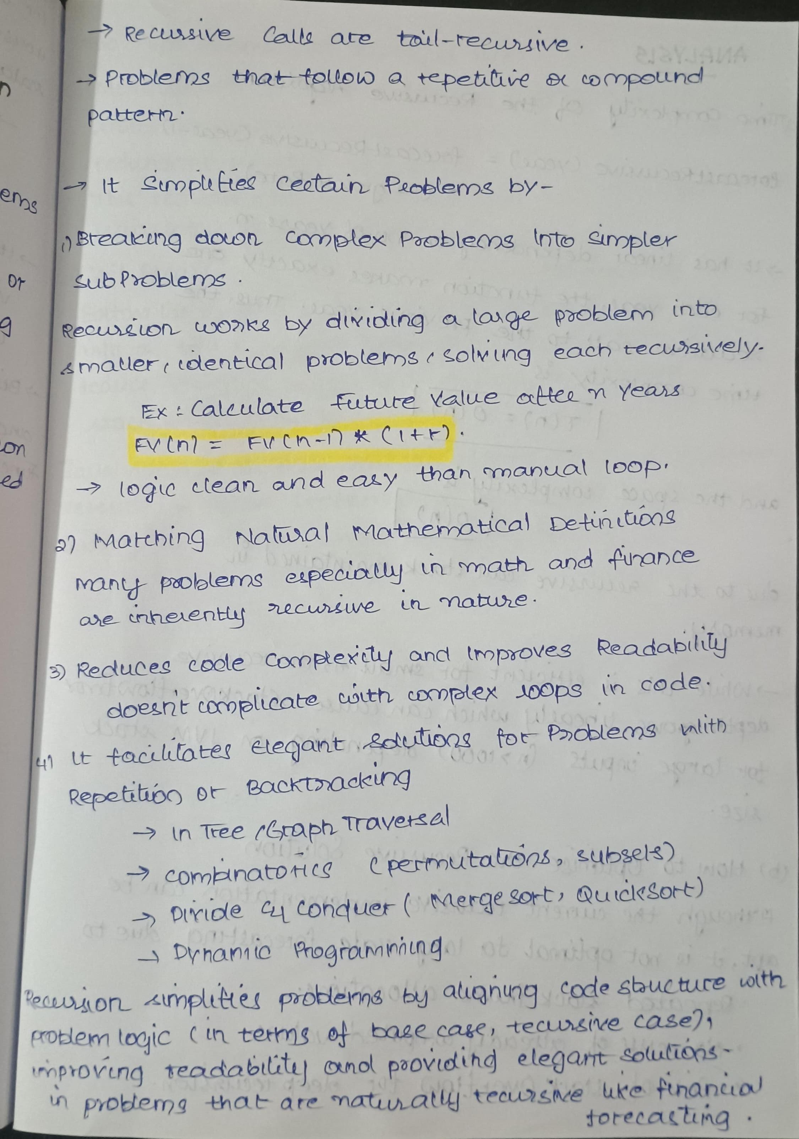

IMPLEMENTATION:

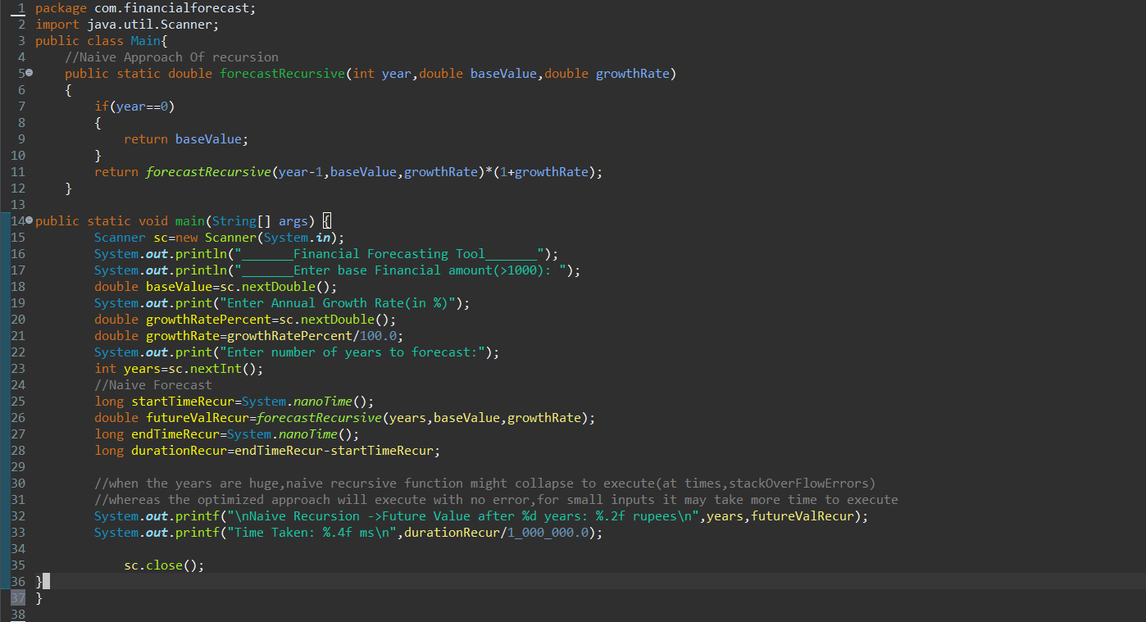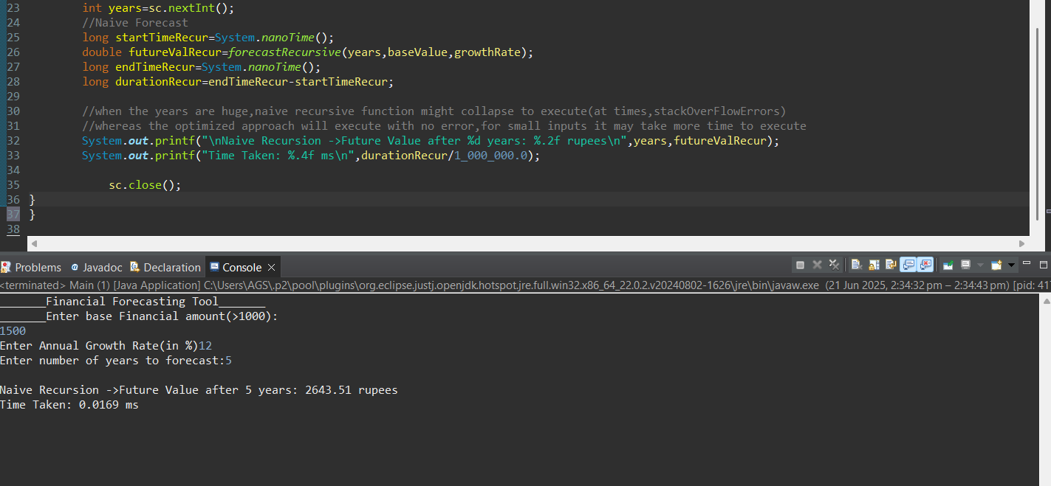

OUTPUT:

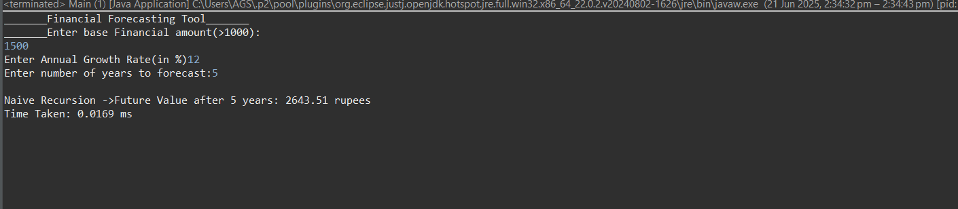

ANALYSIS: